Destiny b**r**ought them together

and now love will seal their bond....forever

Please join us to celebrate the Wedding Ceremony of

Prisha

Daughter of Parin Patel and Jyotika Patel

&

Pranay

Son of Rajesh Shah and Vandana Shah

Saturday 31st March 2018

Barat Arrival - 5:00 pm

Muhurat - 5:30 pm

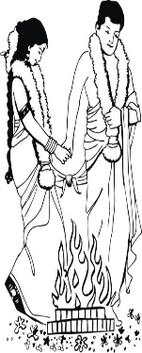******

**LOGOS/SYMBOLS IN THE DOCUMENT CAN BE CHANGED (IF REQUIRED) TO THE LOGOS/SYMBOLS CHOSEN FROM OUR LIBRARY.**[**CLICK HERE**](https://drive.google.com/drive/folders/1mexxxOBpusGDXVfdDxVjYFbjZXUkjlB6) **TO BROWSE OUR LIBRARY OF LOGOS/SYMBOLS.**

At

The Hellenic Function Centre

31 Crombie Avenue, Bundall QLD 4217

No Boxed Gifts Please

RSVP: Parin - 0430 410 646

by 15 Feb 2018

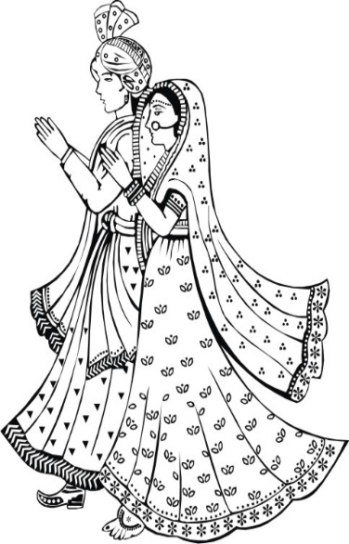******

Mr. Parin Patel and Mrs. Jyotika Patel

&

Mr. Rajesh Shah and Mrs. Vandana Shah

Request the honour of your presence for a night of

Celebration at the Wedding Reception of

Prisha

&

Pranay

Saturday 31st March 2018

8:00 pm Sharp

Followed by Dinner

**LOGOS/SYMBOLS IN THE DOCUMENT CAN BE CHANGED (IF REQUIRED) TO THE LOGOS/SYMBOLS CHOSEN FROM OUR LIBRARY.**[**CLICK HERE**](https://drive.google.com/drive/folders/1mexxxOBpusGDXVfdDxVjYFbjZXUkjlB6) **TO BROWSE OUR LIBRARY OF LOGOS/SYMBOLS.**

At

The Hellenic Function Centre

31 Crombie Avenue, Bundall QLD 4217

No Boxed Gifts Please

RSVP: Parin - 0430 410 646

by 15 Feb 2018